AVL tree is a self balanced binary search tree. That means, an AVL tree is also a binary search tree but it is a balanced tree. A binary tree is said to be balanced, if the difference between the hieghts of left and right subtrees of every node in the tree is either -1, 0 or +1. In other words, a binary tree is said to be balanced if for every node, height of its children differ by at most one. In an AVL tree, every node maintains a extra information known as balance factor. The AVL tree was introduced in the year of 1962 by G.M. Adelson-Velsky and E.M. Landis.

**An AVL tree is defined as follows**: An AVL tree is a balanced binary search tree. In an AVL tree, balance factor of every node is either -1, 0 or +1.

Balance factor of a node is the difference between the heights of left and right subtrees of that node. The balance factor of a node is calculated either height of left subtree - height of right subtree (OR) height of right subtree - height of left subtree. In the following explanation, we are calculating as follows...

Balance factor = heightOfLeftSubtree – heightOfRightSubtree

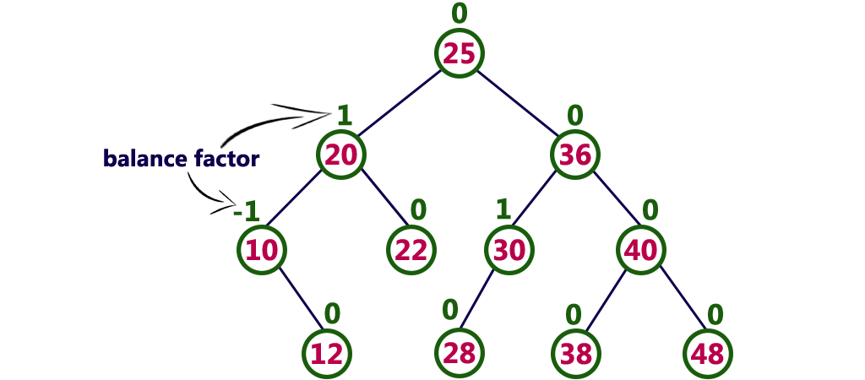

The above tree is a binary search tree and every node is satisfying balance factor condition. So this tree is said to be an AVL tree.

**AVL Tree Rotations**

In AVL tree, after performing every operation like insertion and deletion we need to check the balance factor of every node in the tree. If every node satisfies the balance factor condition then we conclude the operation otherwise we must make it balanced. We use rotation operations to make the tree balanced whenever the tree is becoming imbalanced due to any operation.

Rotation operations are used to make a tree balanced.

**There** are four rotations and they are classified into two types.

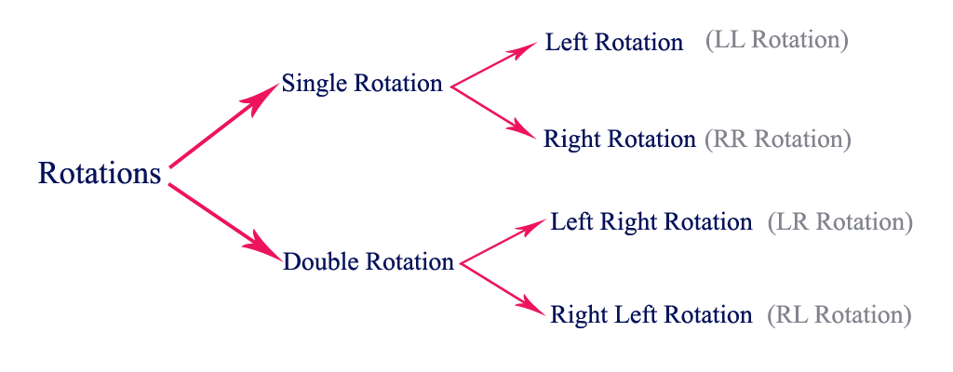

**Single Left Rotation (LL Rotation)**

In LL Rotation every node moves one position to left from the current position. To understand LL Rotation, let us consider following insertion operations into an AVL Tree...

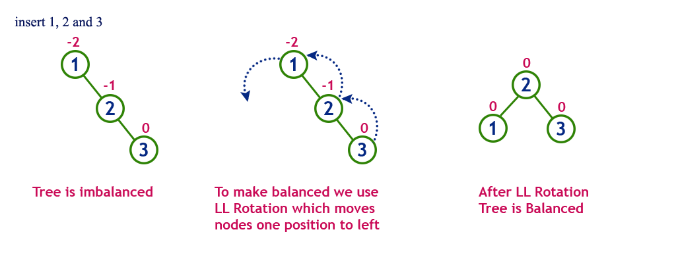

**Single Right Rotation (RR Rotation)**

In RR Rotation every node moves one position to right from the current position. To understand RR Rotation, let us consider following insertion operations into an AVL Tree...

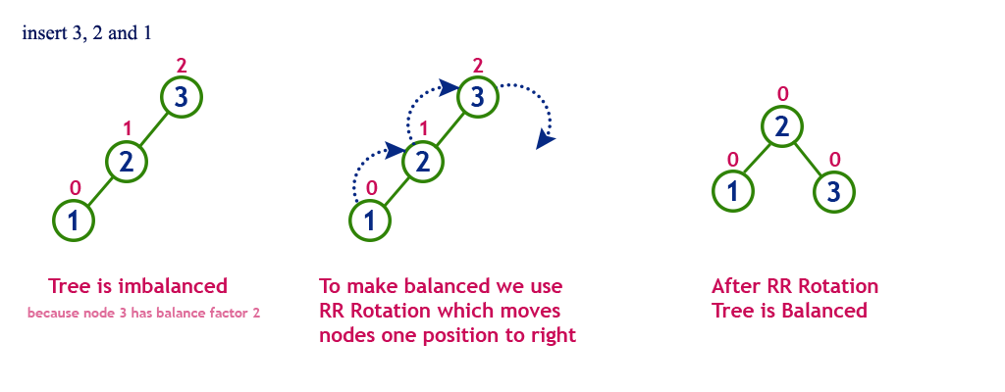

**Left Right Rotation (LR Rotation)**

The LR Rotation is combination of single left rotation followed by single right rotation. In LR Roration, first every node moves one position to left then one position to right from the current position. To understand LR Rotation, let us consider following insertion operations into an AVL Tree...

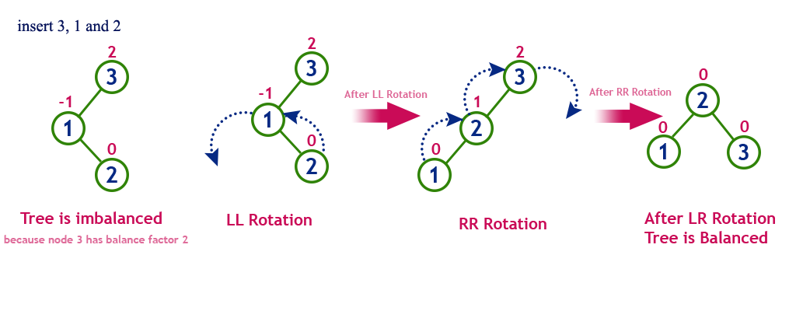

**Right Left Rotation (RL Rotation)**

The RL Rotation is combination of single right rotation followed by single left rotation. In RL Roration, first every node moves one position to right then one position to left from the current position. To understand RL Rotation, let us consider following insertion operations into an AVL Tree...

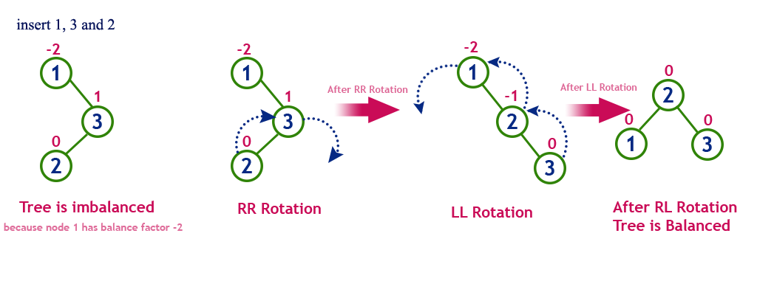

Operations on an AVL Tree

**The following operations are performed on an AVL tree...**

1. Search
2. Insertion
3. Deletion

**Search Operation in AVL Tree**

In an AVL tree, the search operation is performed with **O(log n)** time complexity. The search operation is performed similar to Binary search tree search operation. We use the following steps to search an element in AVL tree...

* **Step 1:** Read the search element from the user
* **Step 2:** Compare, the search element with the value of root node in the tree.
* **Step 3:** If both are matching, then display "Given node found!!!" and terminate the function
* **Step 4:** If both are not matching, then check whether search element is smaller or larger than that node value.
* **Step 5:** If search element is smaller, then continue the search process in left subtree.
* **Step 6:** If search element is larger, then continue the search process in right subtree.
* **Step 7:** Repeat the same until we found exact element or we completed with a leaf node
* **Step 8:** If we reach to the node with search value, then display "Element is found" and terminate the function.
* **Step 9:** If we reach to a leaf node and it is also not matching, then display "Element not found" and terminate the function.

**Insertion Operation in AVL Tree**

In an AVL tree, the insertion operation is performed with O(log n) time complexity. In AVL Tree, new node is always inserted as a leaf node. The insertion operation is performed as follows...

**Step 1**: Insert the new element into the tree using Binary Search Tree insertion logic.

**Step 2:** After insertion, check the Balance Factor of every node.

**Step 3:** If the Balance Factor of every node is 0 or 1 or -1 then go for next operation.

**Step 4:** If the Balance Factor of any node is other than 0 or 1 or -1 then tree is said to be imbalanced. Then perform the suitable Rotation to make it balanced. And go for next operation.

**Example: Construct an AVL Tree by inserting numbers from 1 to 8.**

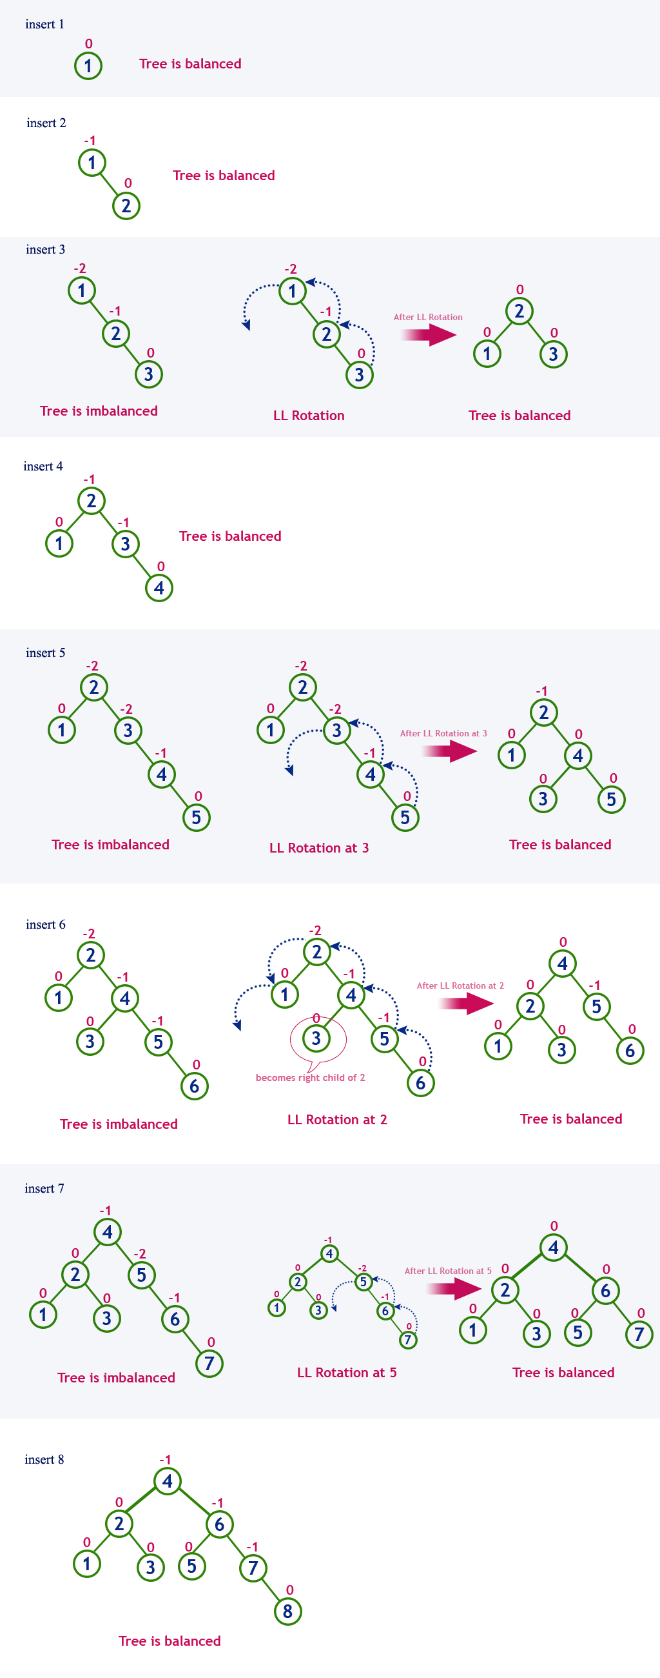

**Deletion Operation in AVL Tree**

In an AVL Tree, the deletion operation is similar to deletion operation in BST. But after every deletion operation we need to check with the Balance Factor condition. If the tree is balanced after deletion then go for next operation otherwise perform the suitable rotation to make the tree Balanced.